**“LAB MST Experiment”**

Student Name: **SUMIT KUMAR** UID: **20BCS8226**

Branch: **CSE** Section/Group: **808-A**

Semester: **5** Date of Performance: **25-08-22**

Subject Name: **PBLJ Lab** Subject Code: **20CSP-321**

**AIM**:

Create an application to save the employee information using arrays.

**Minimum Hardware Requirements:**

* 2 GHz CPU or 1 virtual CPU in virtualized environments.
* 1 GB of RAM.
* 4 GB of storage.

**Minimum Software Requirements:**

|  |  |
| --- | --- |
| **Software** | **Version** |
| * OS | * Mac OS 10.15, HP-UX 11i V3, AIX 7.2, Windows Server 2019, Windows 10, Solaris 11.3, Red Hat Enterprise Linux 8.1, Ubuntu Server 20.04 |
| * JDK | * JDK 1.8.0, JDK 11, Ellipse IDE, Net, NetBeans 8.2, Notepad++ |

**Source Code:**

// SUMIT KUMAR

// UID: 20BCS8226

// Save: Employee.java

**package** sumit;

**import** java.util.*;

**public** **class** Employee {

**public** **static** **void** main(String[] args) {

// **TODO** Auto-generated method stub

**int** i,f=0,pos = -1,da=0,salary;

**char** empDes;

String empid[]={"1001","1002","1003","1004","1005","1006","1007"};

String depName[]={"R&D","PM","Acct","Front Desk","Engg","Manufacturing","PM"};

String empName[]={"Raaj","Sushma","Rahul","Ravi","Ranjan","Sumit","Saurav"};

String dateJoin[]={"1/04/2009","23/08/2012","12/11/2008","29/01/2013","16/07/2005","1/01/2000","12//06/2006"};

**int** basic[]={20000,30000,10000,12000,50000,23000,29000};

**int** hra[]={8000,12000,8000,6000,20000,9000,12000};

**int** it[]={3000,9000,1000,2000,20000,4400,10000};

String desg = **null**;

**char** DesCodes[]={'e','c','k','r','m','e','c'};

Scanner in = **new** Scanner(System.***in***);

System.***out***.println("Enter empid: ");

String s = in.next();

**for**(i=0;i<(empid.length);i++)

{

**if**(args[0].equals(empid[i]))

{

pos=i;

//f=1;

}

}

**if**(pos==-1)

{

System.***out***.println("Emp id does not exist");

**return**;

}

//System.out.println("Hello");

empDes=DesCodes[pos];

**switch**(empDes)

{

**case** 'e':

desg="Engineer";

da=20000;

**break**;

**case** 'c':

desg="Consultants";

da=32000;

**break**;

**case** 'k':

desg="Clerk";

da=12000;

**break**;

**case** 'r':

desg="Receptionist";

da=15000;

**break**;

**case** 'm':

desg="Manager";

da=40000;

**break**;

}

salary=basic[pos]+hra[pos]+it[pos]+da;

//System.out.println(salary);

System.***out***.println("Emp no\t\tEmployee Name\t\tDeaprtment\t\tDesignation\t\tSalary");

System.***out***.println(empid[pos]+"\t\t\t"+empName[pos]+"\t\t\t"+depName[pos]+"\t\t\t"+desg+"\t\t"+salary);

}

}

**Output:**

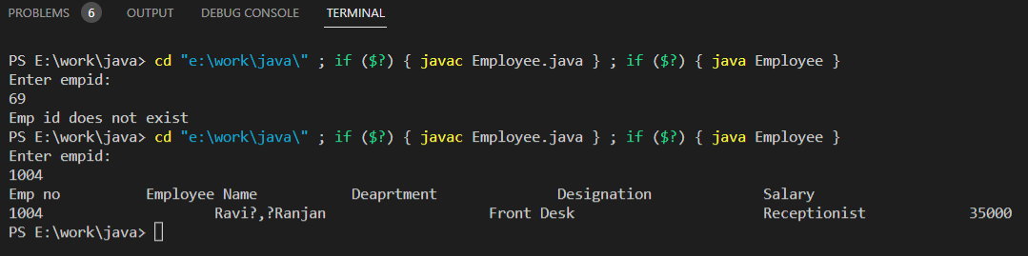

**Learning outcomes:**

* Learnt about getter and setter method.
* Learnt about factory method.
* Learnt to make code more efficient and maintainable by using Code refactoring.
* Learnt how to implement object-oriented designs with Java.
* Learnt how to use exception handling in Java applications.